**Covid-19 Expert Interview Round 4**

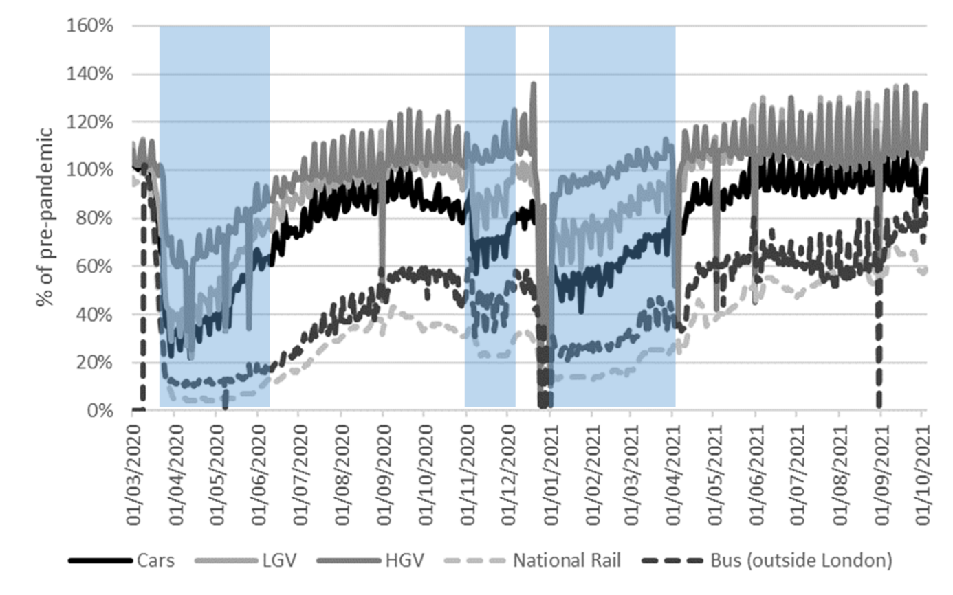

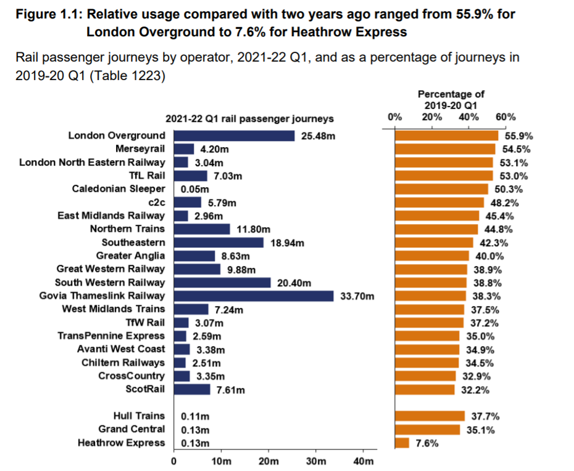

**Where are we now?**

A tailored set of questions based on previous rounds of interviews for each respondent. For some, this section was very short.

Operators have told us that bus use is around 70% of pre-pandemic levels. What is your understanding of the current state of play?

How have tram and rail usage compared? When we last spoke ….

You felt that any increases in cycling that had been seen in …. were largely ……. Was there any bounce in early Autumn in cycle commuter use? Has cycle use gone back to pre-pandemic levels? Are there any specific success stories you can point to with data?

When we last spoke you said that traffic levels were *back to pre-pandemic levels* but just with a different profile (no peak). What are they are at now?

You described the response to Covid as a car based recovery…. Would you still characterise this as a car-based recovery?

Nationally freight levels are also up, particularly light vans. Is this the case in xxx?

How would you describe the way the economic activity in the city centre?

You talked about the challenges of rapid delivery of active travel measures, criticisms over consultation…. How quickly are you now able to deliver these schemes?

Are we doing anything quicker now than pre-pandemic?

**Current Strategy/Operational/Implementation**

In xxxxx you published your transport plan out to 20xx. Has Covid emboldened xxxx or is this pretty much what you would have had planned?

Have you as officers felt able to do things differently?

Has anything become less possible?

Have you made any assessment of the impacts of Covid on income from xxxx if fewer people are commuting? Have businesses yet begun to respond to this?

You talked about needing an xx% reduction in traffic to meet your carbon goals. How far do you think your current plan gets you towards this target?

Has the impact of Covid-19 on public transport set back what will be achievable?

**Looking ahead**

If we presume we have reached an endemic state by March next year what do you think the future will look like?

When we last spoke in May you said you were shooting in the dark in terms of your models. Do you feel any more confident now?

What would the implications of going backwards in restrictions be?

If another pandemic hit in 5-10 years what would you do differently and how different would your start point be?

Has anyone in government asked you about what you would advise is done differently?

Who is leading on learning from the pandemic in the transport sector in your area?